Ideation Phase
Brainstorm & Idea Prioritization Template

Date | 03 October 2026
Team ID | SWTID-2026-6471
Project Name | EduGenie: Google Gemini Powered Learning Assistant
Maximum Marks | 4 Marks

Step-1: Team Gathering, Collaboration and Select the Problem Statement
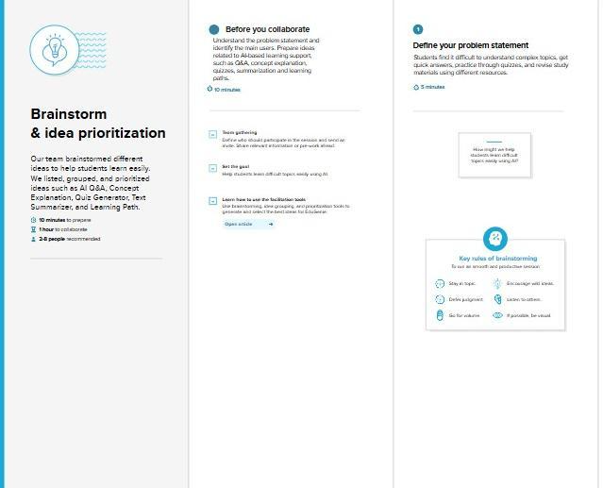

Step-2: Brainstorm, Idea Listing and Grouping
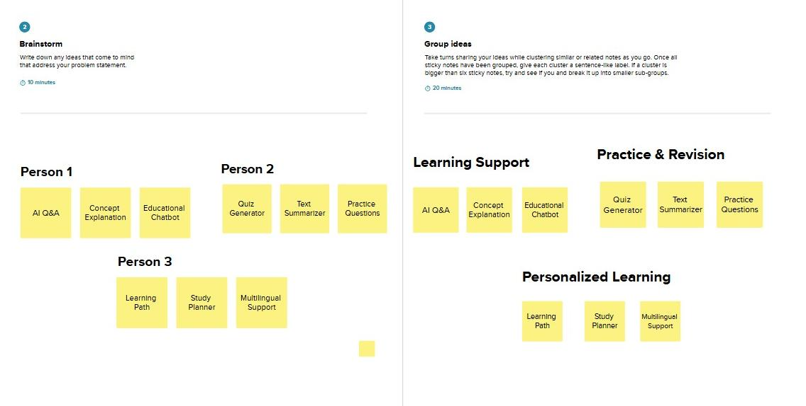

Step-3: Idea Prioritization
